Directions: Cut out all of the boxes on this page to glue onto the diagram

Plants take in water

Animals take in oxygen through breathing

C₆H₁₂O₆
Plants release oxygen.

O₂

Animals exhale carbon dioxide.

Plants use this process to produce glucose from sunlight

C₆H₁₂O₆

O₂

Animals release water. Water evaporates into the atmosphere

H₂O
Animals undergo respiration to produce energy

CO₂
H₂O

Animals take in glucose through eating
Plants take in carbon dioxide

CO₂

Directions: Cut out and glue the boxes onto the correct part of the diagram below to complete the photosynthesis/respiration cycle.
This symbol means that a text box should be glued over that place (X marks the spot!)
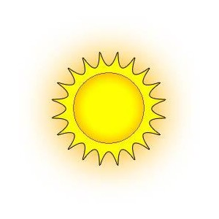
Photosynthesis and Respiration
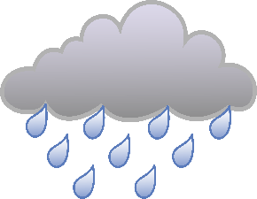

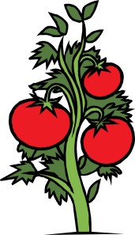
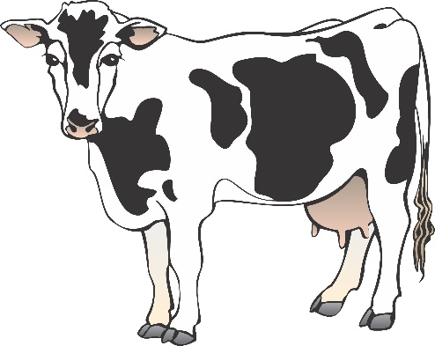
Photosynthesis
Respiration Respiration

Part 2: Photosynthesis and Respiration Equations
On this page, glue down the different chemical formulas to complete each equation, then answer the questions below.
Photosynthesis Equation

Respiration Equation

- Plants have to go through respiration too, how would a plant go through respiration? Describe the process.

- Explain how the CO₂ that animals release is created. Where do each of the atoms come from?

- When humans burn fuel such as oil or wood, it release large amounts of CO₂ into the air. How do you think this might affect the photosynthesis/respiration cycle?

