Name: __________________________ Handout: __________
Date: __________________

Title: Observation versus Inference notes.
- Observation
An observation is information that you gather directly from your senses: Sight, Smell, Hearing, Taste, Touch

- Inference
An inference is an educated guess based on your past experiences and prior knowledge.
We use inferences to explain observations.
Example:
Observation: The lawn was wet as I walked through it this morning.
Possible inferences:
It could have rained last night.
The sprinkler could have been on.
There is dew on the grass from the fog.

Example: You observe a student sitting in the main office.
List two inferences you could make about this observation:
1.

2.

Fill in the chart with observations and inferences about the classroom.
Observations | Inferences
1.  2. | 1.  2.
Practice
Your task is to determine if the following are observations or inferences. Put an O in front the observation and an I in front of the inferences.

____ 1. The temperature at noon was 78 degrees.
____ 2. It is a very hot day.
____ 3. The price of gasoline is rising.
____ 4. Bill’s car is very fast.
____ 5. The test was very easy.
____ 6. The candle weighed 71 grams.
____ 7. The test tube felt hot.
____ 8. The flowers did not grow due to the lack of sunshine.
____ 9. The dimension of the card is 3” x 5”.
____ 10. The Amoeba moved toward the light.
____ 11. The price of gasoline is unreasonable.
____ 12. There are three blue rulers on the table.
____ 13. Judging by the clouds, it will probably rain this afternoon.
____ 14. The toy car is red.
____ 15. The room is very quiet.
____ 16. Poodles are awesome.

Write two observations and two inferences about the picture below.

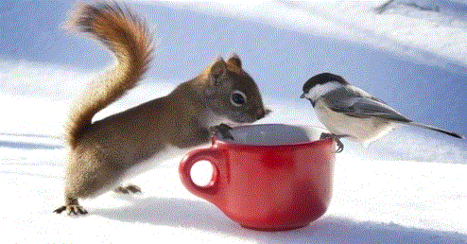
Observations:
1.

2.

Inferences:
1.

2.

